# Service Name: No Dues Certificate

## Process Flow / Procedure

* Citizen can apply for the service on Web, Aaple Sarkar, and Mobile App or can visit to CFC/ULB office. On Web, he can upload the supporting mandatory documents.
* Pay the prescribed fees either Online (Credit Card/Debit Card/Net Banking) or Offline (At ULB/CFC).
* Application no. is generated which is further can be used by applicant to track the application.
* Applicant will be informed through SMS and email for every important event.
* Verification of documents will be done at ULB/CFC counter. Citizen needs to submit the copies of the documents at the ULB counter in case of ULB (CFC) application or needs to upload documents in case of online application.
* ULB/CFC clerk will check all the documents and authorize or Un-authorize the application.
* If application is un-authorized then citizen can re-submit document or can correct the application form.
* If application is authorized then it will be scrutinized (if applicable) by the respective department.
* Later, Citizen will avail the digitally signed certificate against the service applied through online login or from the ULB/CFC counter.
* Timeline to complete the Services

|  |  |
| --- | --- |
| Services | No. of days |
| No dues Certificate | 3 |

## Service Workflow

## 

## Document Checklist

|  |  |  |
| --- | --- | --- |
| Services | Required documents from Citizen | Documents verified by ULB |
| No Due Certificate | NA | Check Property dues in system with Property Number |

## Screenshots

* Step1: Click on “Property” module link to Apply for No Dues Certificate. On clicking following screen will be displayed by the system

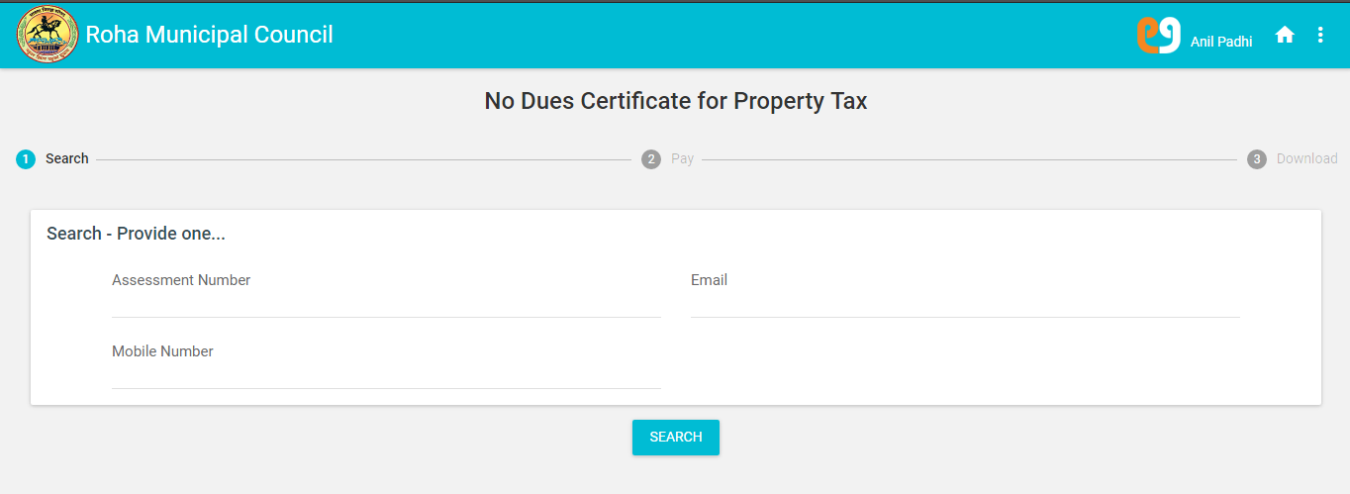

* Step 2: User should enter provided search parameters and click on Search button. On clicking, page will be redirect to the “No dues Certificate for Property tax” page

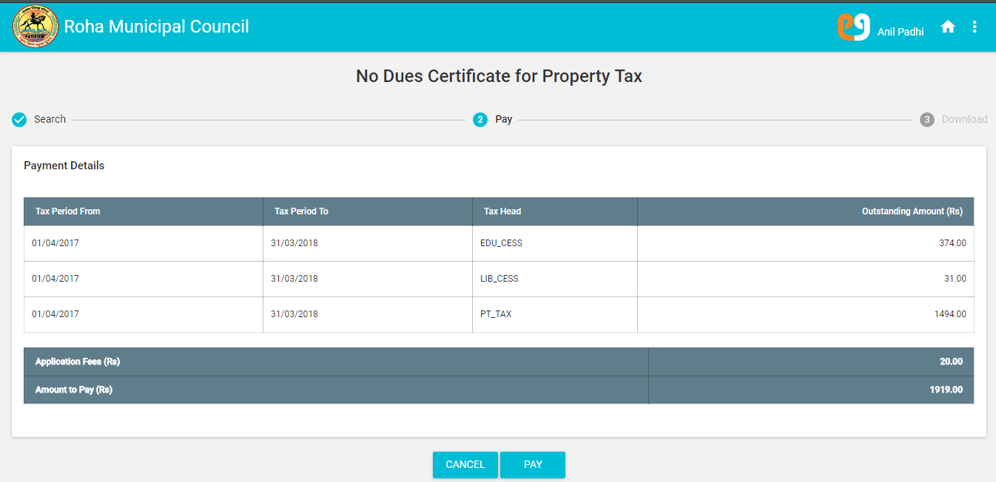

* Step 3: User should click on “Pay” button to proceed with payment. After Clicking on Pay Button, page will be redirect to the Mahaonline Payment Mode Page

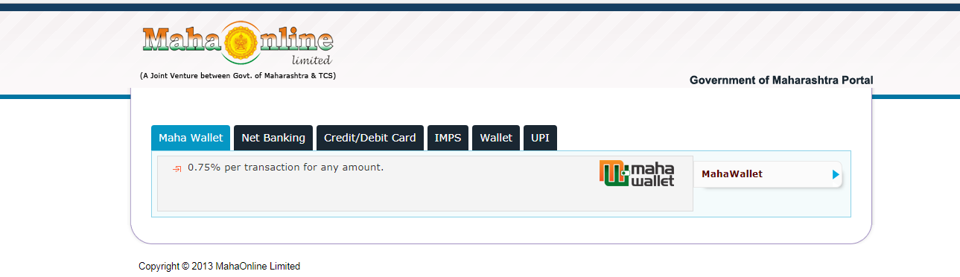

* Step 4: After Clicking on Net banking Option on the Mahaonline Payment Mode Page it will redirect to the Net Banking Option Page

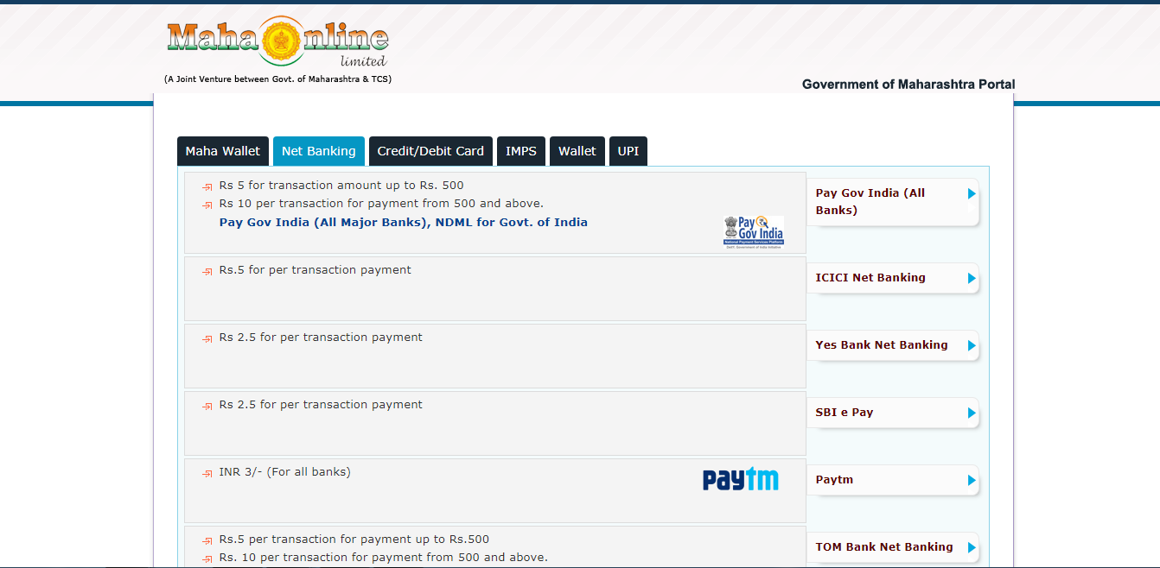

* Step 5: After Clicking on Yes Bank Net banking Option on the Mahaonline Payment Mode Page it will redirect to the Payment Details Page.

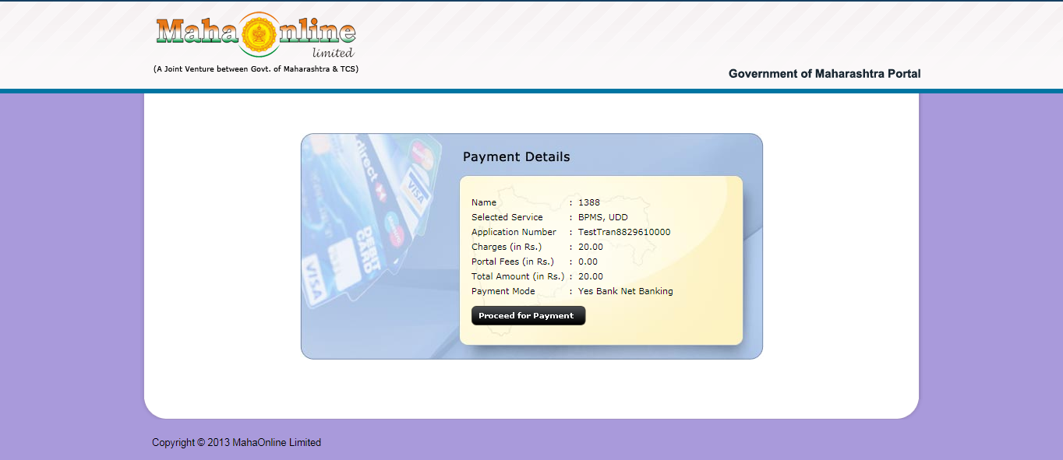

* Step 6: After Clicking “Proceed for Payment” button on the Mahaonline Payment Mode Page it will redirect to the Atom Payment Option Page.

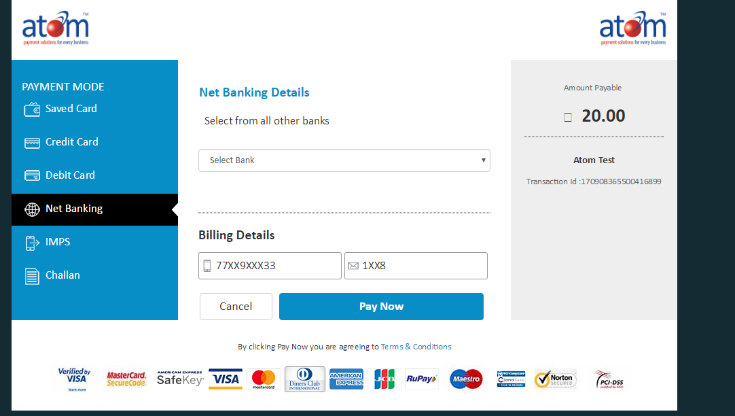

* Step 7: After selecting Net banking Option and selecting Bank As Atom bank clicking on Pay Now button it will redirect to the Atom Transaction Page.

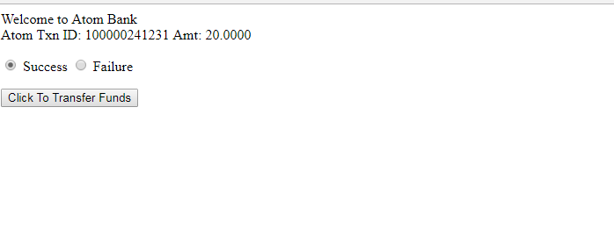

* Step 8: After Clicking on Click To Transfer Funds button it display the below message

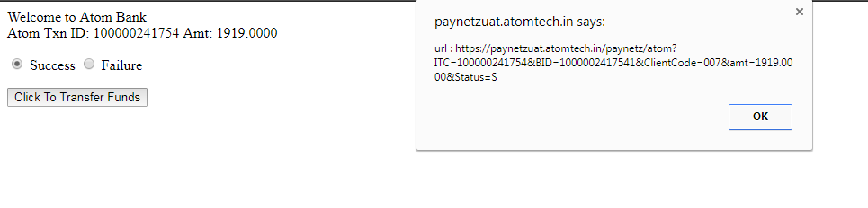

* Step 9: After clicking on Ok Button of the message displayed on the above screen it generates No Due Certificate For Property Tax

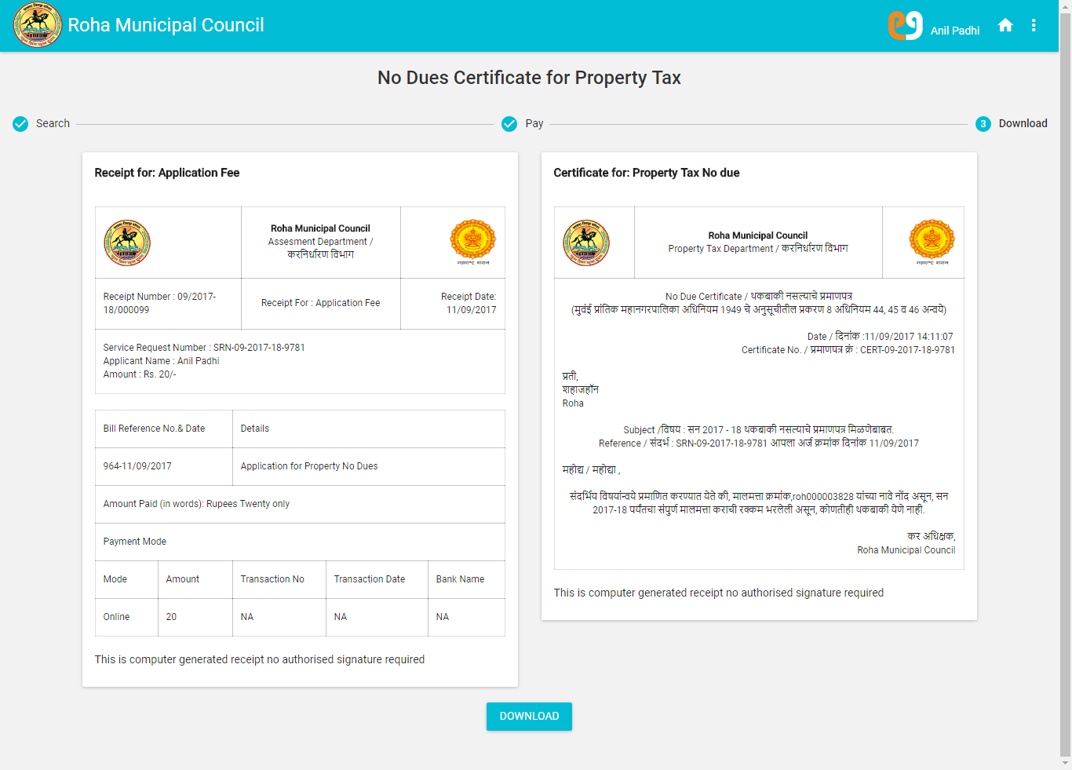

* Step 10: After Clicking on the Download button on the No Dues Certificate for Property Tax page it should allow to take the print of the same. Below is the print preview for the same.

